1. Agenda:
   1. Enhance the limits service to pick the properties from the properties file instead of hard coding into controller.
2. 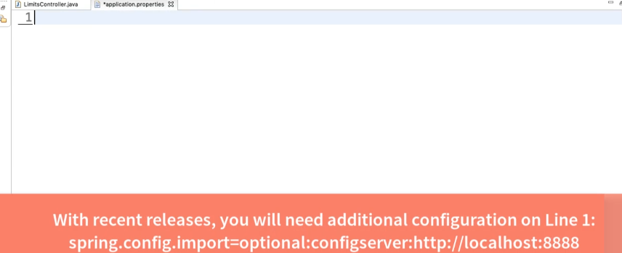
3. 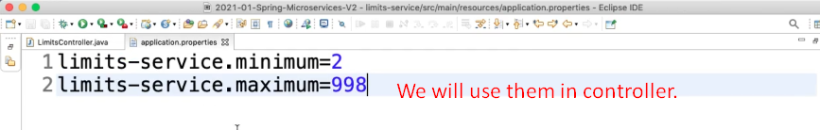
4. 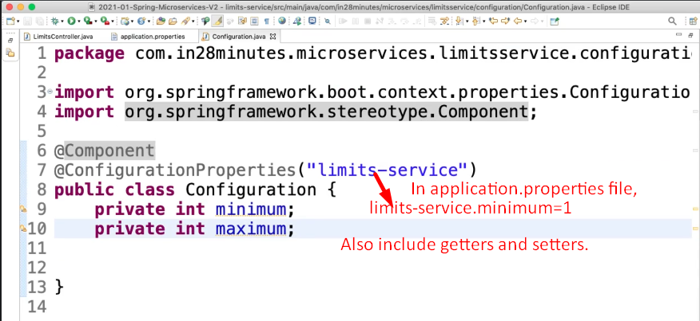
5. 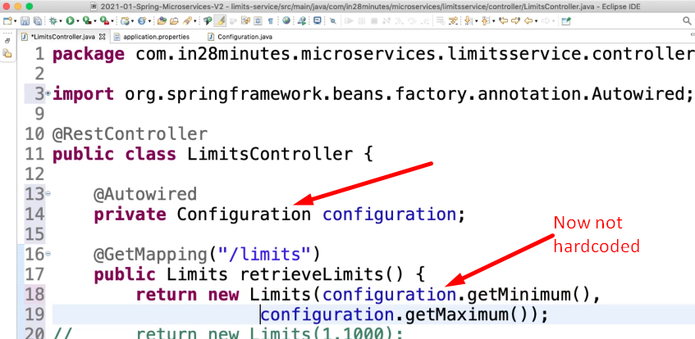
6. 